PHENIKAA UNIVERSITY

PHENIKAA SCHOOL OF COMPUTING



WEEKLY REPORT

TOPIC: ELECTRONICS E-COMMERCE WEBSITE

Course Class : | Software Architecture-1-2-25 (N01)
Instructor : | M.Sc. Vũ Quang Dũng
Group : | 16
Group Members : | Nguyễn Tuấn Thiền - 23010571  Đặng Việt Anh – 23010689

Table of Contents
Lab 03
Table of Contents 2
1. Overview 3
2. Project Structure 3
3. UML Diagrams 4
3.1 Component Diagram 4
3.2 Class Diagram 6
3.3 Sequence Diagram (Create Product) 6
4. Implementation Details 7
4.1 Persistence Layer (Repository) 7
4.2 Business Logic Layer (Service) 9
4.3 Presentation Layer (Controller + Routes) 10
5. Dependency Injection Bindings 11
6. Dependency Verification (Proof of Concept) 12
7. Testing Results (Document 3: Lecture 03 Slide 19) 13
7.1 CRUD Endpoint Summary 14
8. References 15

1. Overview
In Lab 03, we implement the Product Management CRUD feature using a strict 3-layer architecture (Presentation – Business Logic – Persistence). This report is based on the actual Laravel source code in the app/Lab03/ directory of the webbanhang-master project.
The implementation applies the Repository Pattern and Service Pattern with interface-based Dependency Injection. Each layer only communicates with the layer immediately below it, following the strict rule: Controller → Service → Repository.
Technology stack: Laravel (PHP), Eloquent ORM, MySQL database, RESTful API endpoints.

2. Project Structure
The layered components are organized inside app/Lab03/ as a self-contained module with its own Controllers, Services, Repositories, Providers, and routes:
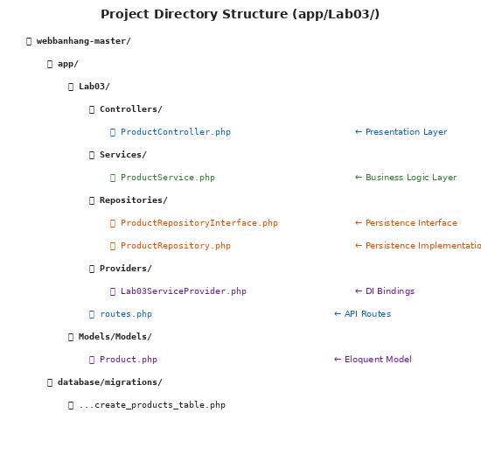
Figure 2.1: Project Directory Structure — app/Lab03/ (Document 1: Lecture 03 Slide 19)
Layer | File | Namespace / Responsibility
Presentation | ProductController.php | App\Lab03\Controllers — Handles HTTP requests, delegates to Service
Business Logic | ProductService.php | App\Lab03\Services — Validation, business rules, orchestration
Persistence (Interface) | ProductRepositoryInterface.php | App\Lab03\Repositories — Contract for data access
Persistence (Impl) | ProductRepository.php | App\Lab03\Repositories — Eloquent-based data access
DI Provider | Lab03ServiceProvider.php | App\Lab03\Providers — Binds interfaces to implementations
API Routes | routes.php | RESTful endpoints: GET/POST/PUT/DELETE /api/lab03/products

3. UML Diagrams

3.1 Component Diagram
The Component Diagram shows the four architectural layers with UML component notation (lollipop = provided interface, socket = required interface) and strict downward dependency flow:
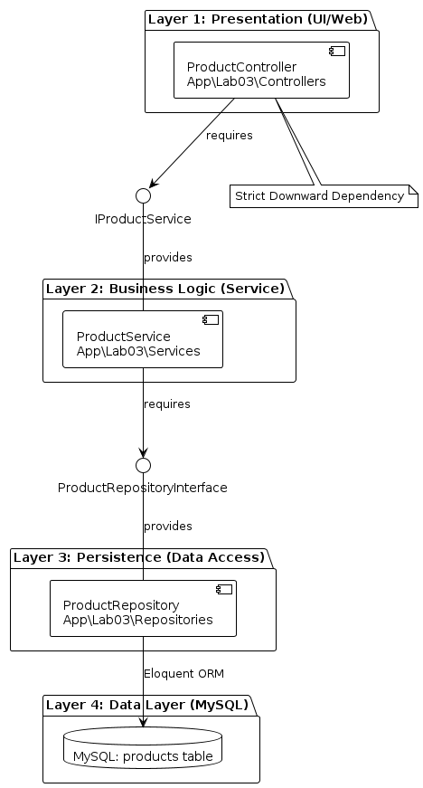
Figure 3.1: UML Component Diagram — Controller → Service → Repository → Database

3.2 Class Diagram
The Class Diagram shows all classes, interfaces, their methods, and relationships (implements, depends on, uses):
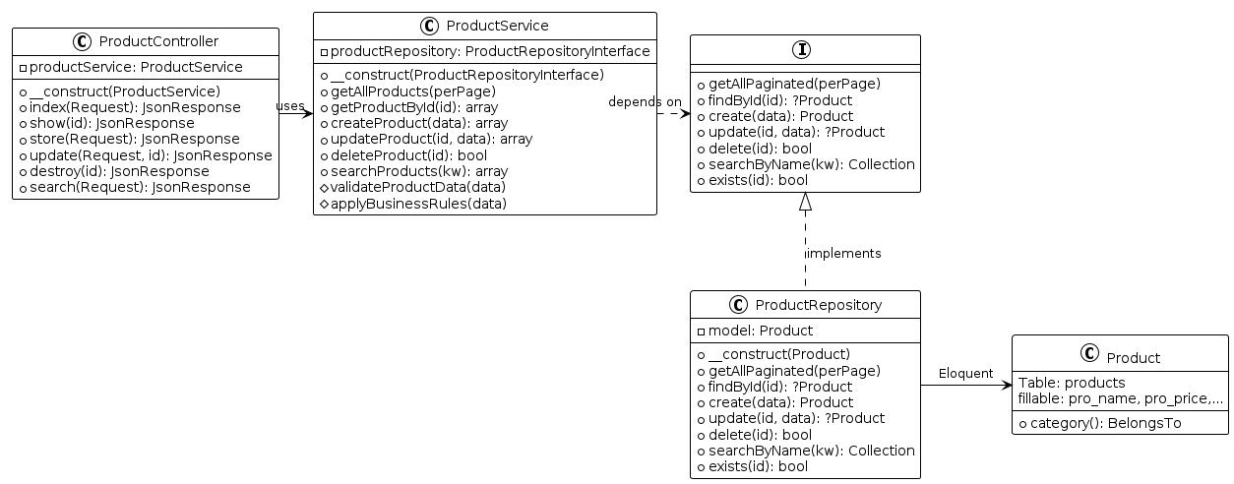
Figure 3.2: UML Class Diagram — Interfaces + Implementations

3.3 Sequence Diagram (Create Product)
The Sequence Diagram illustrates the full request flow for POST /api/lab03/products, including both the success path (HTTP 201) and the failure path (HTTP 400 when business rule is violated):
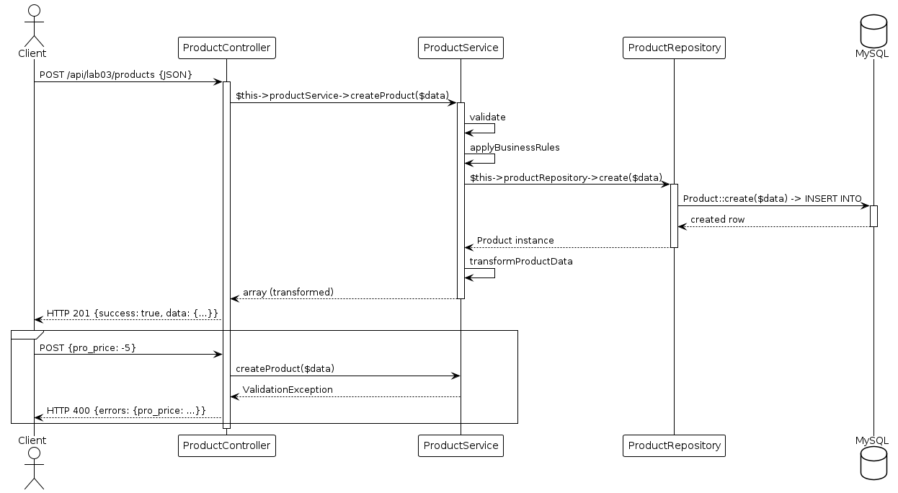
Figure 3.3: UML Sequence Diagram — Create Product (success + validation failure)

4. Implementation Details

4.1 Persistence Layer (Repository)
The Repository layer handles all direct data access via Eloquent ORM. It implements the ProductRepositoryInterface contract.
File: app/Lab03/Repositories/ProductRepositoryInterface.php
<?php
namespace App\Lab03\Repositories;

interface ProductRepositoryInterface
{
public function getAllPaginated(int $perPage = 15);
public function getAll(): Collection;
public function findById(int $id): ?Product;
public function create(array $data): Product;
public function update(int $id, array $data): ?Product;
public function delete(int $id): bool;
public function searchByName(string $keyword): Collection;
public function exists(int $id): bool;
}
File: app/Lab03/Repositories/ProductRepository.php (key methods)
class ProductRepository implements ProductRepositoryInterface
{
protected $model;
public function __construct(Product $product)
{ $this->model = $product; }

public function create(array $data): Product
{
if (!isset($data['pro_slug']) && isset($data['pro_name']))
$data['pro_slug'] = Str::slug($data['pro_name']).'-'.time();
$data['pro_active'] = $data['pro_active'] ?? 1;
$data['pro_hot'] = $data['pro_hot'] ?? 0;
return $this->model->create($data);
}

public function findById(int $id): ?Product
{ return $this->model->find($id); }

public function update(int $id, array $data): ?Product
{
$product = $this->findById($id);
if (!$product) return null;
if (isset($data['pro_name']))
$data['pro_slug'] = Str::slug($data['pro_name']).'-'.$product->id;
$product->update($data);
return $product->fresh();
}

public function delete(int $id): bool
{ $p = $this->findById($id); return $p ? $p->delete() : false; }
}

4.2 Business Logic Layer (Service)
The Service layer contains validation and business rules. It depends only on ProductRepositoryInterface (strict downward dependency).
File: app/Lab03/Services/ProductService.php (key methods — Document 2: Lecture 03 Slide 19)
class ProductService
{
protected $productRepository;

// Strict downward: Service -> Repository Interface
public function __construct(ProductRepositoryInterface $productRepository)
{ $this->productRepository = $productRepository; }

public function createProduct(array $data): array
{
$this->validateProductData($data); // Business Rule check
$this->applyBusinessRules($data); // Slug, hot, active
$product = $this->productRepository->create($data);
Log::info("Product created: {$product->id}");
return $this->transformProductData($product);
}

// === BUSINESS RULES (Lecture 03: price must be positive) ===
protected function validateProductData(array $data): void
{
$rules = [
'pro_name' => 'required|string|max:255',
'pro_price' => 'required|numeric|gt:0', // price > 0
'pro_category_id' => 'required|integer|exists:category,id',
];
$validator = Validator::make($data, $rules);
if ($validator->fails())
throw new ValidationException($validator);
}

protected function applyBusinessRules(array &$data): void
{
// Calculate sale price
if (isset($data['pro_sale']) && $data['pro_sale'] > 0)
$data['pro_total'] = $data['pro_price']
* (1 - $data['pro_sale']/100);
// Mark as hot if price > 10M VND
if (($data['pro_price'] ?? 0) > 10000000)
$data['pro_hot'] = 1;
// Auto-deactivate if no stock
if (($data['quantity'] ?? -1) == 0)
$data['pro_active'] = 0;
}
}

4.3 Presentation Layer (Controller + Routes)
The Controller handles HTTP requests and delegates to the Service. It does NOT import Repository or Eloquent Model for CRUD operations.
File: app/Lab03/Controllers/ProductController.php (key methods)
class ProductController extends Controller
{
protected $productService;

// Layer 1: Controller -> Service only (no Repository!)
public function __construct(ProductService $productService)
{ $this->productService = $productService; }

// POST /api/lab03/products
public function store(Request $request): JsonResponse
{
try {
$product = $this->productService->createProduct($request->all());
return response()->json([
'success' => true,
'message' => 'Product created successfully',
'data' => $product
], 201);
} catch (ValidationException $e) {
return response()->json([
'success' => false,
'message' => 'Validation failed',
'errors' => $e->errors()
], 400);
}
}

// GET /api/lab03/products
public function index(Request $request): JsonResponse
{
$products = $this->productService->getAllProducts(
$request->get('per_page', 15));
return response()->json([
'success' => true, 'data' => $products
], 200);
}
}
File: app/Lab03/routes.php
Route::prefix('api/lab03')->group(function () {
Route::prefix('products')->group(function () {
Route::get('/', [ProductController::class, 'index']);
Route::get('/search', [ProductController::class, 'search']);
Route::get('/{id}', [ProductController::class, 'show']);
Route::post('/', [ProductController::class, 'store']);
Route::put('/{id}', [ProductController::class, 'update']);
Route::delete('/{id}',[ProductController::class, 'destroy']);
});
});

5. Dependency Injection Bindings
The Lab03ServiceProvider binds the interface to its concrete implementation, enabling Laravel to auto-inject the correct Repository when constructing the Service:
File: app/Lab03/Providers/Lab03ServiceProvider.php
class Lab03ServiceProvider extends ServiceProvider
{
public function register(): void
{
$this->app->bind(
ProductRepositoryInterface::class,
ProductRepository::class
);
}
public function boot(): void
{
$this->loadRoutesFrom(__DIR__ . '/../routes.php');
}
}

6. Dependency Verification (Proof of Concept)
As required by Lecture 03 (Slide 13), we verify the strict dependency rule by examining the import statements of each layer:
File (Layer) | Imports | Verification
ProductController (Layer 1) | use App\Lab03\Services\ProductService | ✅ Only imports Service (L1→L2). Does NOT import Repository or Product model for CRUD.
ProductService (Layer 2) | use App\Lab03\Repositories\ProductRepositoryInterface | ✅ Only imports Repository Interface (L2→L3). Does NOT import any Controller or HTTP class.
ProductRepository (Layer 3) | use App\Models\Models\Product | ✅ Only imports Eloquent Model (L3→DB). Does NOT import Service or Controller.

Conclusion: No layer skips a level, and no upward dependency exists. The strict rule Controller → Service → Repository → Database is enforced by code structure and DI bindings.

7. Testing Results (Document 3: Lecture 03 Slide 19)
The following API tests demonstrate the full CRUD flow and business rule enforcement. The flow follows: Client → Controller → Service → Repository → Eloquent → MySQL.
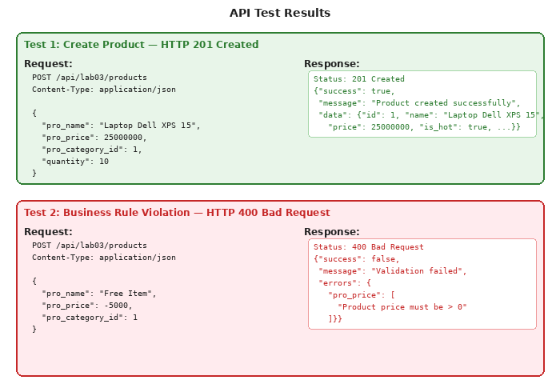
Figure 7.1: API Test Results — POST 201 (Success) + POST 400 (Business Rule Violation)

7.1 CRUD Endpoint Summary
Method | Endpoint | Operation | Expected Response
GET | /api/lab03/products | List (Read) | 200 OK + JSON array
GET | /api/lab03/products/{id} | Show (Read) | 200 OK / 404 Not Found
POST | /api/lab03/products | Create | 201 Created / 400 Bad Request
PUT | /api/lab03/products/{id} | Update | 200 OK / 400 / 404
DELETE | /api/lab03/products/{id} | Delete | 200 OK / 404 Not Found
GET | /api/lab03/products/search?q= | Search | 200 OK + results

8. References
Lab 3: Layered Architecture Implementation (CRUD) — Course Materials
Lecture 3: Layered Monolith Implementation (CRUD) — Software Architecture Course
Lab 2: Layered Architecture Design (Logical View) — Course Materials
Lab 1 Report: Requirements Elicitation, ASRs, and Use Case Modeling

